1 Install nginx and run nginx on port number 81.?
Ans_ Install Nginx and Run on Port 81 — Simple Steps
- Update the Ubuntu package list.
- Install Nginx on the Ubuntu server.
- Open the Nginx configuration file.
- Change the default port from 80 to 81.
- Save the configuration file.
- Test the Nginx configuration to make sure there are no errors.
- Restart Nginx to apply the changes.
- Allow port 81 in the firewall and AWS Security Group.
- Open a web browser and enter the server IP with port 81.
- Verify that the Nginx welcome page is displayed.
Result: Nginx is successfully installed and running on port 81.
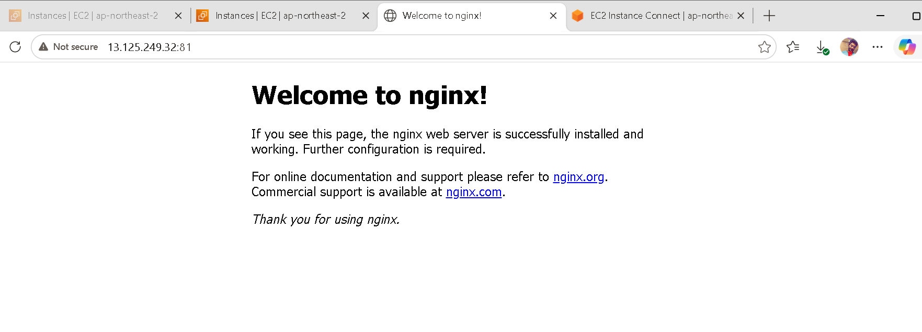

2.Deploy a sample index.html file on nginx.?
Ans • Open the Ubuntu Virtual Machine and access the terminal.
• Navigate to the Nginx web directory.
• Create or open the index.html file.
• Add sample HTML content to the file.
• Save and close the index.html file.
• Restart the Nginx service to apply the changes.
• Open a web browser on the local computer.
• Enter the server IP address along with the Nginx port number.
• Verify that the sample webpage is displayed correctly.
• The sample index.html file has been successfully deployed on Nginx.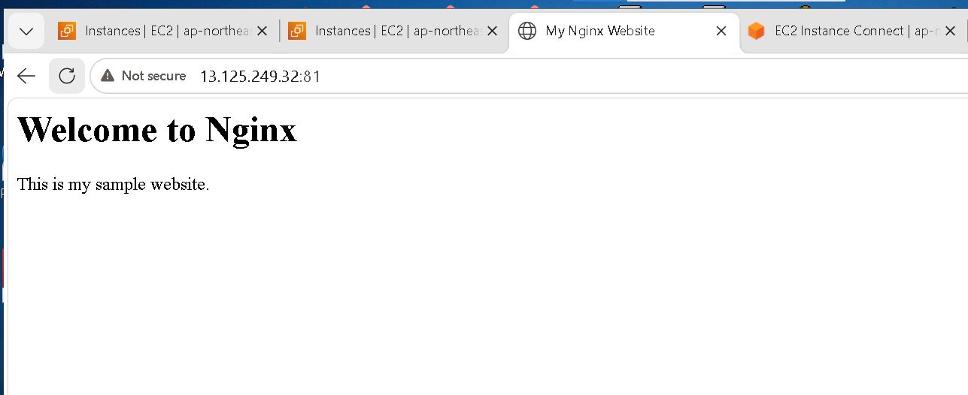

3 Install Apache and run Apache on port number 82 ?
• Open the Ubuntu Virtual Machine and access the terminal.
• Update the system package information.
• Install the Apache web server.
• Open the Apache ports configuration file.
• Change the default Apache port from 80 to 82.
• Save the configuration file.
• Restart the Apache service.
• Check that Apache is running successfully.
• Open a web browser.
• Enter the server IP address with port 82.
• Verify that the Apache default webpage is displayed.
• Apache is now successfully running on port 82.
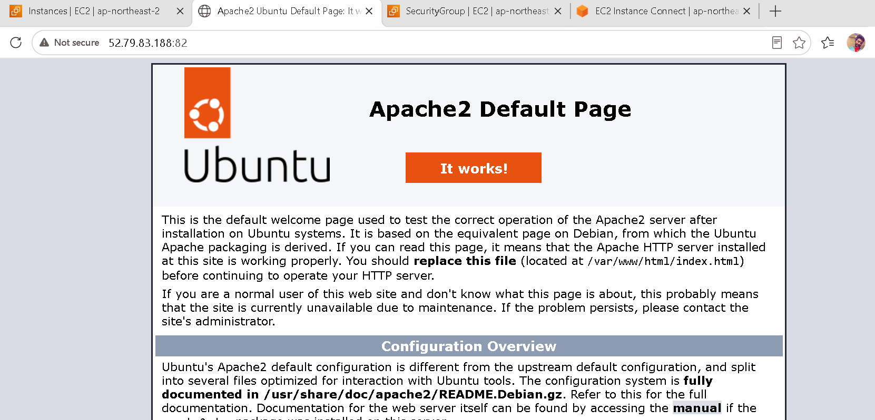
4 )Deploy a sample index.html file on Apache ?

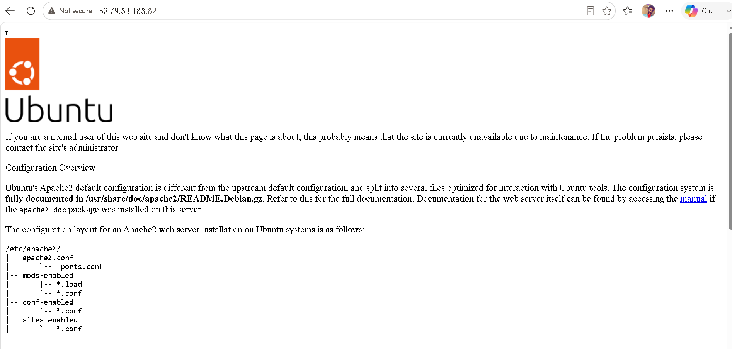

05) Install Apache tomcat on port number 8082 ?
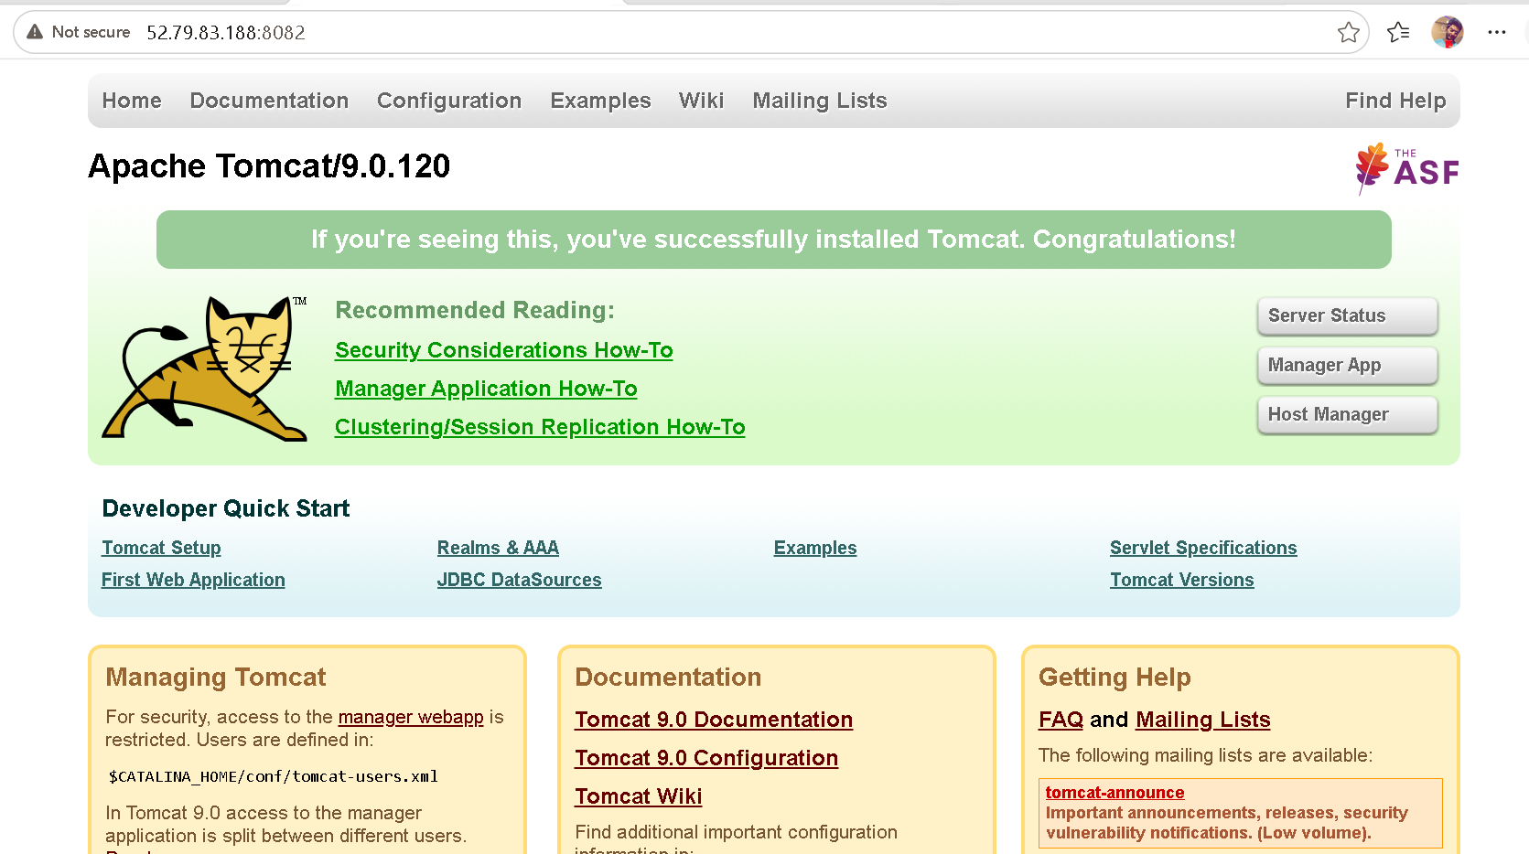

6

• Open the Ubuntu terminal.
• Go to the Tomcat folder.
• Open the webapps folder.
• Create a new folder named sampleapp.
• Open the sampleapp folder.
• Create a file named index.html.
• Add simple HTML content such as “Welcome to My Sample App”.
• Save the index.html file.
• Make sure the sampleapp folder is inside the Tomcat webapps directory.
• Restart the Tomcat server.
• Open a web browser.
• Enter:
http://YOUR-SERVER-IP:8082/sampleapp/
• The Sample App page should appear.
• This confirms that the application has been successfully deployed on Tomcat.

6) Deploy a sample app on webapps ?

- Open the Tomcat installation directory: /opt/tomcat.
- Navigate to the webapps directory.
- Create a new folder named sample.
- Create an index.html file inside the sample folder.
- Add the sample application content to the HTML file.
- Set the appropriate permissions for the application files.
- Restart the Tomcat server.
- Open a web browser and access http://<server-ip>:8080/sample/.
- Verify that the sample application is displayed successfully.

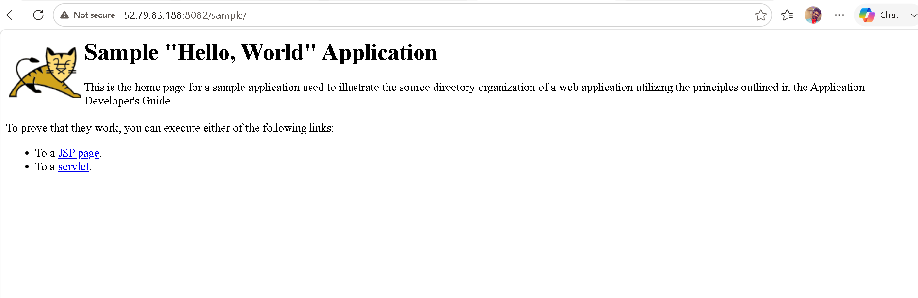

7) Create a tomcat.service file for tomcat.?
Create a tomcat.service file in the service directory
(/usr/lib/systemd/system/)
➔ Configure Tomcat paths and start/stop commands
➔ Relod systemd >> systemsctl daemon-reload
➔ Enable tomcat >> systemsctl enable tomcat
➔ Start tomcat >> systemsctl start tomcat
➔ Check status >> systemsctl status tomcat
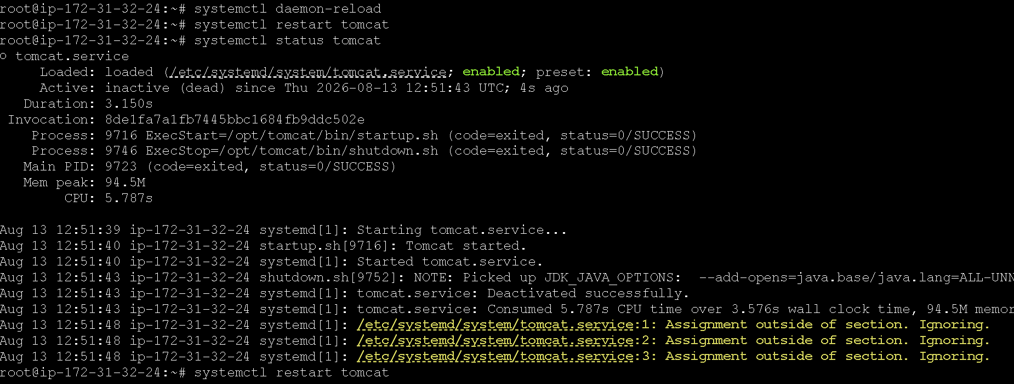
8 ) Configure HA Proxy server ?

1. Set up Server 1
- Create/prepare Server 1.
- Install Apache or Nginx.
- Start the web server.
- Create a simple webpage showing "Server 1".
- Check that the webpage works using Server 1's IP address.
2. Set up Server 2
- Create/prepare Server 2.
- Install Apache or Nginx.
- Start the web server.
- Create a simple webpage showing "Server 2".
- Check that the webpage works using Server 2's IP address.
3. Prepare the HAProxy server
- Create another Ubuntu server for HAProxy.
- Update the packages.
- Install HAProxy.
- Make sure the HAProxy server can communicate with Server 1 and Server 2
